A Project Report On…

# Mobile Shop Management System



Developed By…

**Pragnesh Chavda**

Submitted To…

**Geetanjali Collage of Computer Science & Commerce**

Saurashtra University Rajkot

**2024-2025**

Guide Name…

**PROF. Pranav Trivedi**

# ACKNOWLEDGEMENTS

While the report for my project work is ready, I feel it is my bounden duty to offer my sincere thanks to all those who have helped and guided me in this regard.

Action is very necessary to convert our dreams into reality. My dream was to develop this project. To make a successful and useful project, one needs help, understanding, and coordination from all those who are directly or indirectly involved in this.



Many people have contributed to making this project a reality. I would like to express my gratitude to our **Head of Department**, Prof. **Brijesh Shah**, for his guidance throughout the project.

While submitting the project report, it is my duty to offer my sincere thanks to those who have assisted me in preparing this project report. I would like to express my gratitude to Kishor Singh Vala for his guidance throughout the project. He helped me in the selection of this topic and guided me to the final completion of my project by reviewing the manuscript of the chapters and providing valuable suggestions.

Before I describe my project briefly, I would like to add a few heartfelt words for those people who have given their time and knowledge to developing this project. Last but not least, I am thankful to all my college faculties and friends for their kind cooperation.

# A Special thanks from:

Pragnesh Chavda

# PREFACE

In the 5th semester of my Bscit program, we are required to prepare a project as a separate subject. This project involves thorough study and analysis of a particular subject, followed by the preparation of a comprehensive project report.



There is a significant difference between theoretical and practical knowledge, and understanding this distinction is crucial for the effective use of knowledge. The preparation of a project report has been a new and interesting experience for me. I must admit that it has been challenging from certain perspectives. Through this process, we gain insights into the theoretical concepts of the subject matter and their practical application. A project report also plays a vital role in building confidence in our lives.

It was felt that it is important and instructive not only to learn the principles of software engineering but also to apply them to a software development project. This approach allows us to clearly observe all aspects of development within a project.

By preparing this report, I have come to understand the importance of practical training in the field of education. It is easier to work with a computerized system than a manual one. Thisnot only saves time, effort, and space but also enhances efficiency by generating interest.

Our project pertains to "Mobile Shop management system." The project report contains information and details related to it.

This project is part of my Fifth semester of Bscit course curriculum. Geetanjali Collage of Computer Science & Commerce–Rajkot.

I have decided to develop a web application for my Bscit 5th semester using java technology . Our college has held a prominent position as one of the best colleges in Saurashtra University for a considerable duration.

# Index



|  |  |  |
| --- | --- | --- |
| **NO** | **NAME** | **PAGE NO** |
| 3 | ABSTRACT | 1 |
| 4 | PROJECT SUMMARY | 2 |
| 5 | PROJECT PROFILE | 3 |
| 6 | SYSTEM REQUIREMENT | 4 |
| 7 | TECHNOLOGY REQUIREMENT | 5 |
| 8 | TEST CASES | 6 |
| 9 | DATA DICTIONARY | 7 |
| 10 | SYSTEM DESIGN TOOLS | 10 |
| 11 | SCREEN SHOTS | 13 |
| 12 | FUTURE REQUIREMENTS OF PROJECT | 24 |
| 13 | LIMITATIONS OF PROJECT | 25 |
| 14 | BIBLIOGRAPHY | 26 |

**ABSTRACT**

**Description:** Mobile Shop Management System Using JSP and Servlets

The Mobile Shop Management System is a web-based application designed to streamline the management of mobile sales, inventory, and customer service. Developed using JavaServer Pages (JSP) and Servlets, this system offers a dynamic and interactive platform for mobile shop owners to manage products, track sales, and provide efficient customer service.

### Technologies Used:

1. **JavaServer(JSP)Pages: :**

JSP is used to create dynamic web pages that present information to users. It enables the embedding of Java code into HTML pages, allowing the generation of dynamic content such as product listings, customer profiles, and order statuses.

### Servlets:

Servlets are used to handle HTTP requests and responses, process user inputs, manage session data, and interact with business logic. They act as controllers that bridge the presentation layer (JSP pages) with the business logic and data access layers, enabling smooth operations like inventory management, order processing, and customer interactions.

### Conclusion:

The Mobile Shop Management System, developed using JSP and Servlets, provides a comprehensive and interactive platform for managing mobile shops. The use of JSP for dynamic content presentation and Servlets for handling requests and business logic ensures a scalable and maintainable solution, allowing mobile shop owners to efficiently manage their products, sales, and customer relationships.

# PROJECT SUMMERY

**Project Summary: Mobile Shop Management System**

# Objective:

To develop a comprehensive Mobile Shop Management System that allows shop owners to efficiently manage their inventory, sales, and customer relations. The system aims to provide an intuitive platform for managing product listings, customer profiles, and transactions, while offering advanced features for both shop owners and customers.

# Features:

1. **Admin Dashboard**

The Mobile Shop Admin Dashboard centralizes all business activities, providing an at-a-glance view of key metrics such as sales performance, inventory levels, customer interactions, and notifications. This dashboard ensures that mobile shop owners can manage day-to-day business operations seamlessly.

# Essential functionalities include:

* + Product Management
  + Inventory Control and Tracking
  + Sales Reports and Analytics
  + Order and Delivery Management
  + Customer Management and Feedback

# Product Listing and Purchase Process

Customers can easily browse through available mobile products, view detailed specifications, check stock availability, and place orders. The system ensures that customers can interact directly with the product listings, adding items to their cart and completing transactions smoothly.

# Key functionalities include:

* + Easy Product Search and Filtering
  + Product Details Page with Specifications and Pricing
  + Add to Cart and Checkout
  + Integrated Payment Gateway for Secure Transactions

# Order Management

The system enables shop owners to handle customer orders efficiently, from order placement to delivery. Features such as real-time order tracking, order approval, and automated notifications ensure that the entire process is smooth and customer-friendly.

# Features include:

* + Order Approval and Fulfilment

# Conclusion:

The Mobile Shop Management System offers a streamlined solution for managing all aspects of a mobile

shop, from product listings and sales to customer service and inventory management. The system's

user-friendly admin dashboard, real-time inventory control, and efficient order processing make it a s

and robust platform, ensuring that mobile shop owners can effectively manage their businesses while

enhancing the shopping experience for their customers.



# PROJECT GOAL

By achieving these goals, the Mobile Shope Management System aims to provide a valuable product for j seekers and employers, improving the overall efficiency and effectiveness of the product search

# PROJECT PROFILE

Developed At Developed By Division Project Name Main Pages Web Browser

Operating System Editor

Guided By

: Geetanjali College of Computer Science & Commerce.

: Pragnesh Chavda

: BSCIT Semester 5th

: Mobile Shope

: View Product , Add to Cart, About Us, Contact Us, Login

: Google Chrome

: Windows 11

: Eclipse Ide

: Prof Pranav Trivedi



# SYSTEM REQUIREMENTS

* **Software**
  + Any windows operating system windows 7 to windows 11
  + Web Browser (Google Chrome, Internet Explorer, etc…)
  + Front-End -> Html ,Css,JavaScript
  + Back-End -> Java
  + Database -> Mysql

# Hardware

* + Processor : Intel core i3 and after all

,Css,Jt

* + Back-End -> Java
  + Database -> Mysql

# Hardware

* + Processor : Intel core i3 and after all
  + RAM 2 GB or Higher
  + HDD with 256GB or Higher

# TECHNOLOGY REQUIREMENT

* **Front-End:**

### HTML:

provides the basic structure and content of web pages.

### CSS:

handles the presentation and layout, ensuring that web pages look appealing and are well-designed.

### JavaScript:

adds interactivity and dynamic features, making web pages functional and responsive to user actions.

Together, these technologies form the foundation of web development, enabling the creation of modern, interactive, and visually engaging websites and web applications.

# Back-End: Java:

Java is a widely-used, high-level programming language known for its portability, scalability, and robustness. It is a popular choice for backend development due

to its strong performance, extensive libraries, and mature ecosystem.

# Database:

MySQL is an open-source relational database management system known for its reliability, flexibility, and ease of use. It is widely used for managing and organizing data in various applications, from small projects to large- scale enterprise systems.

# TEST CASE

### User Registration and Login

**Test Case 1.1: User Registration**

* + **Objective:** Verify that a new user can register successfully.

### Steps:

* 1. Navigate to the registration page.
  2. Enter valid user details (name, email, password, etc.).
  3. Click the "Register" button.
  + **Expected Result:** The user should receive a confirmation email, and they should be redirected to the login page.

### Test Case 1.2: User Login

* + **Objective:** Verify that a registered user can log in with correct credentials.

### Steps:

1. Navigate to the login page.
2. Enter valid email and password.
3. Click the "Login" button.
   * **Expected Result:** The user should be logged in and redirected to the dashboard or home page.

### Test Case 1.3: Incorrect Login Credentials

* + **Objective:** Verify that the system handles incorrect login credentials correctly.

### Steps:

1. Navigate to the login page.
2. Enter an incorrect email or password.
3. Click the "Login" button.
   * **Expected Result:** The system should display an error message indicating invalid credentials.

# DATA DICTIONARY

## User :

## 

* Product

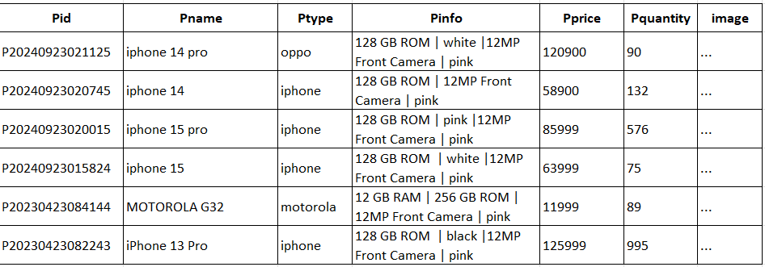

* + - * Cart

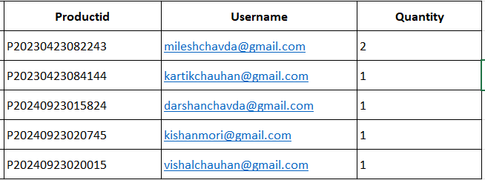

* Orders

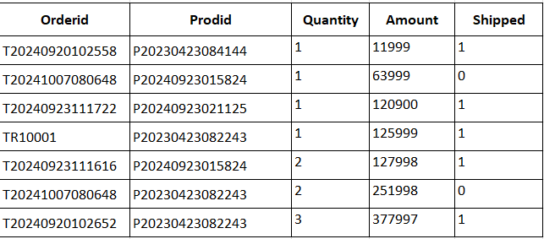

* Transaction



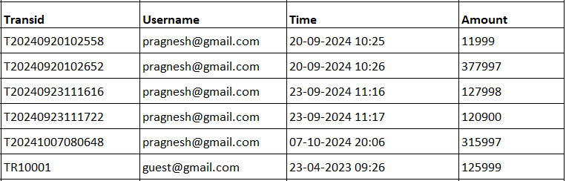

## 

DFD 1 Level Diagram

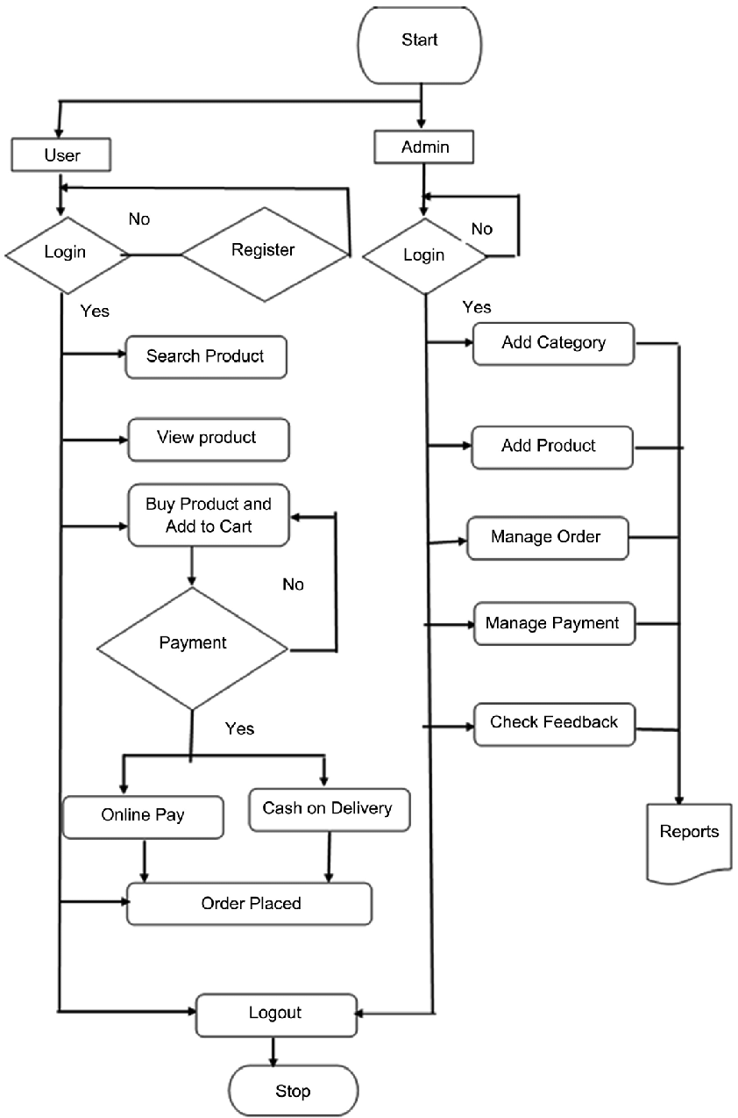

# ER (Entity Relation Diagram)



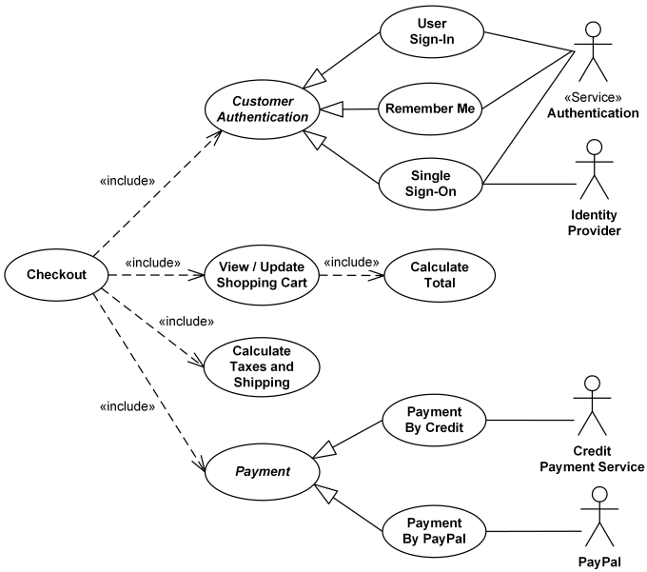

**LAYOUT DESIGN**

# INDEX PAGE

**Page Name: -** Home Page

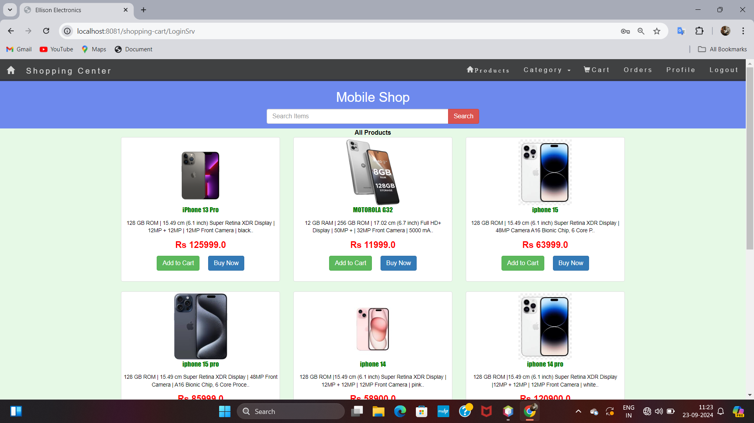

**Page Name: -** Customer Register Page

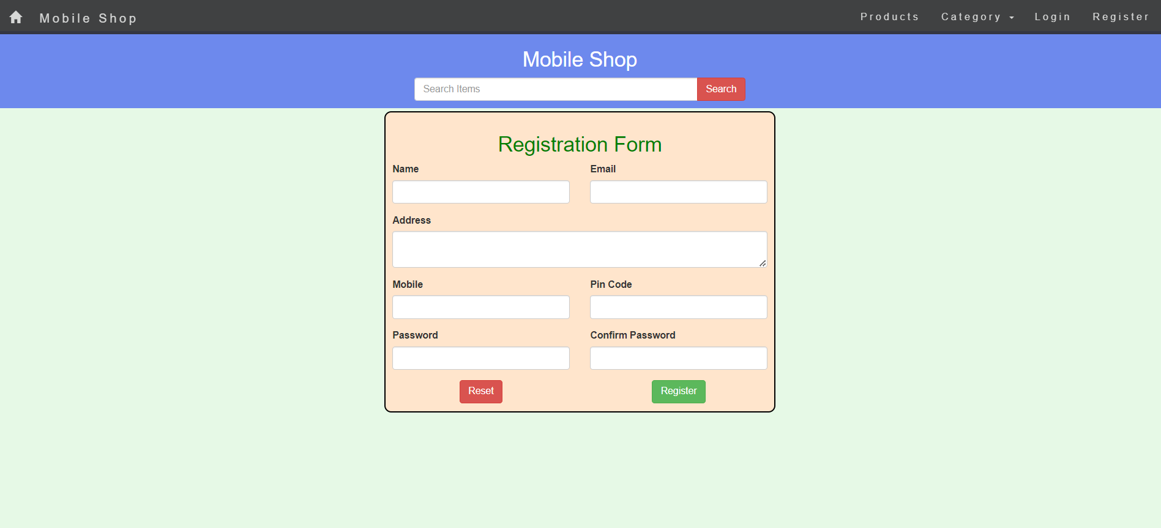

**Page Name: -** Customer Login Page

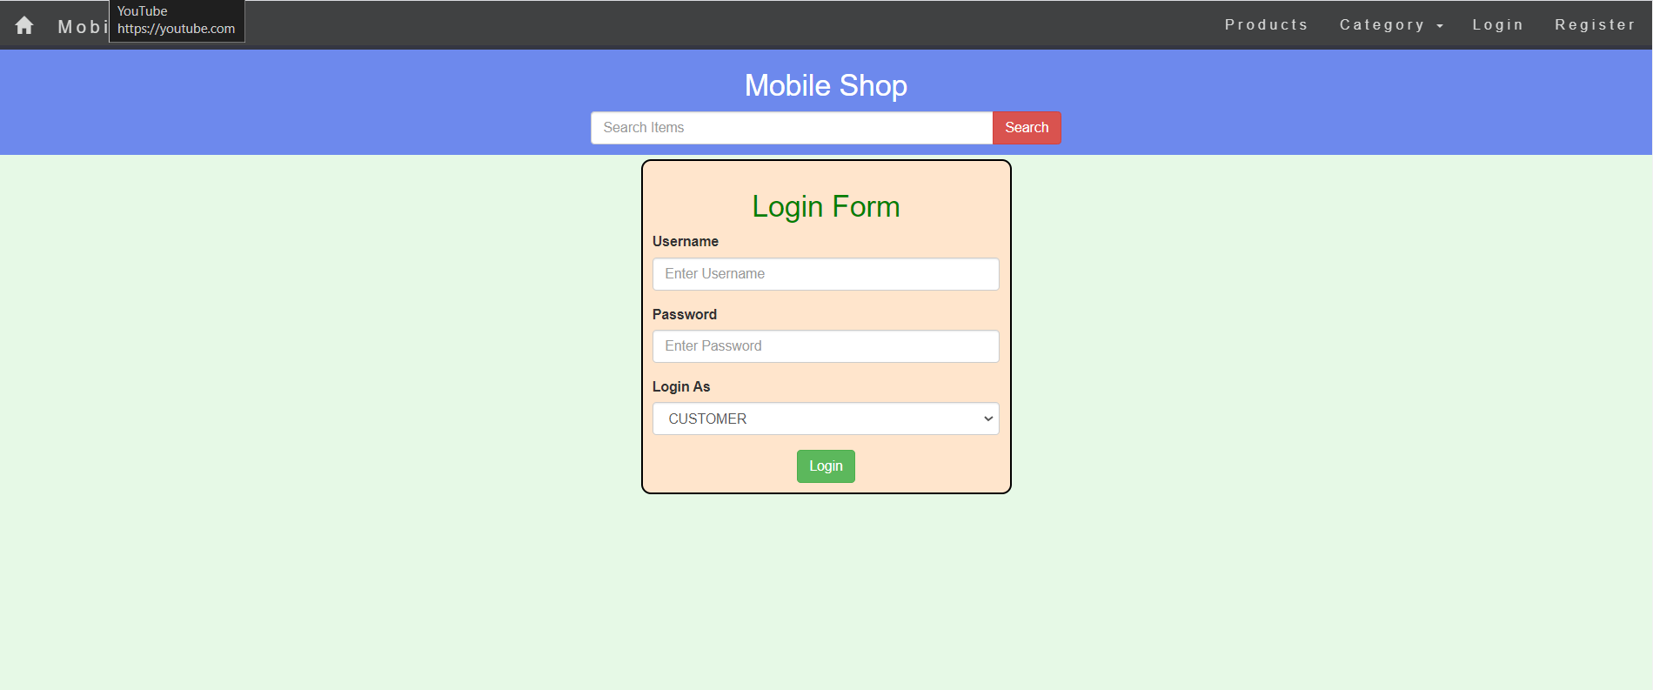

**Page Name: -** Customer Cart page

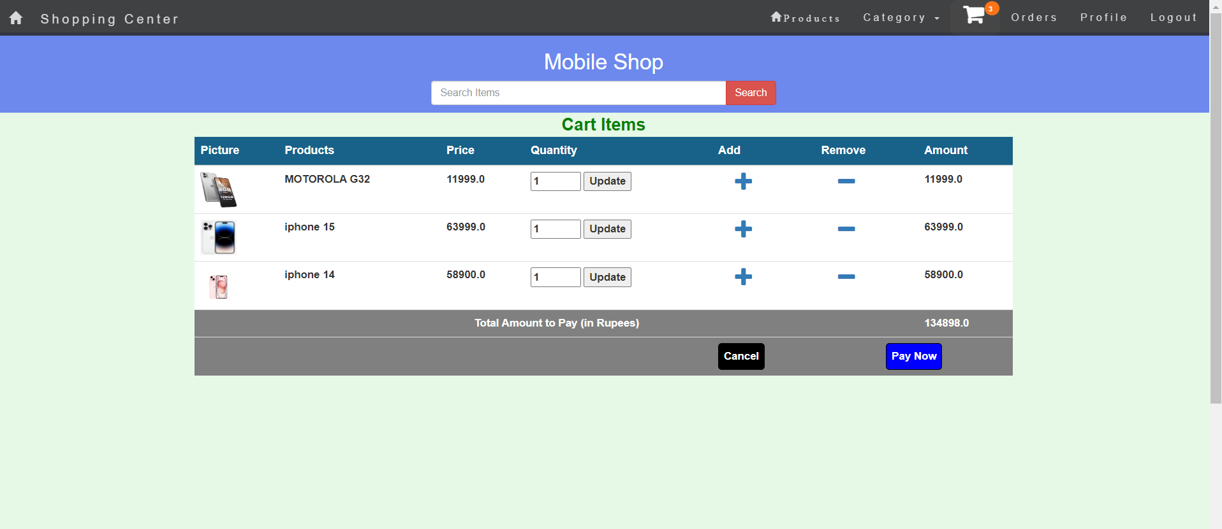

**Page Name: -** Product Page





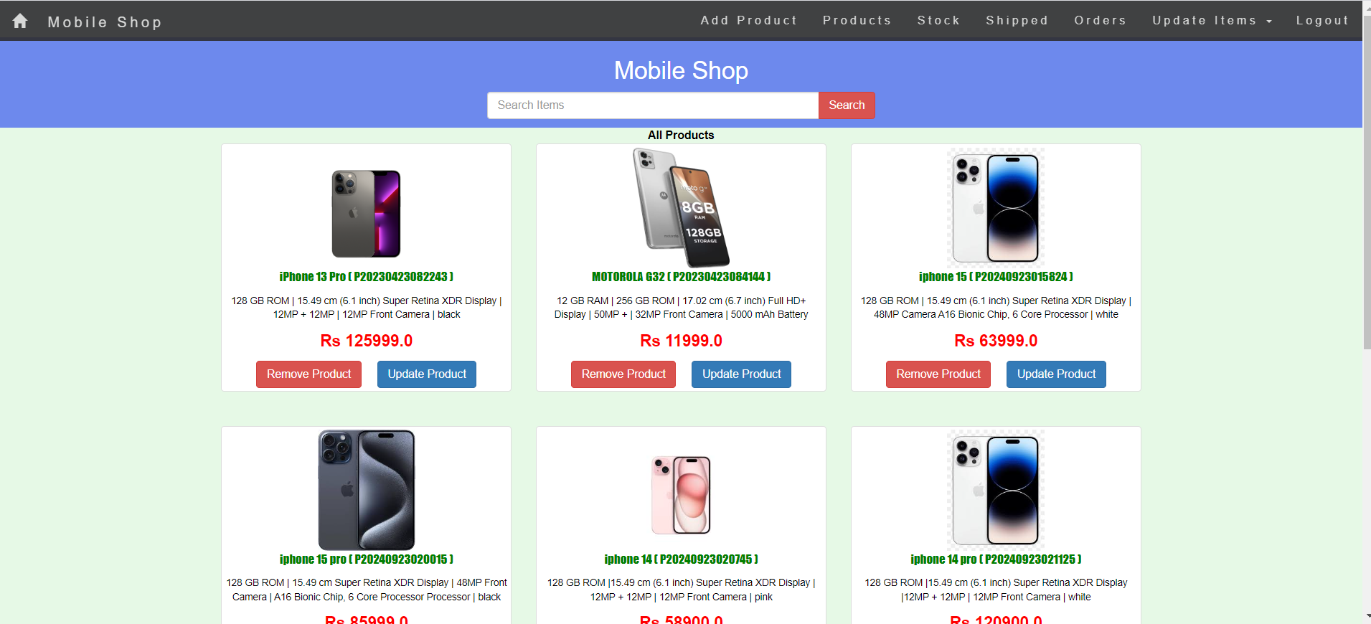**Page Name: -** Admin home

**Page Name: -** Admin View Stock

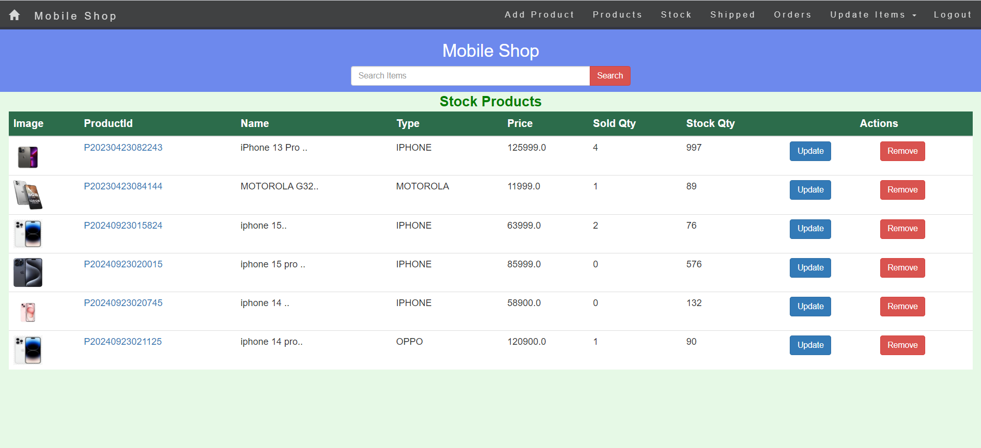



**Page Name: -** Add Product



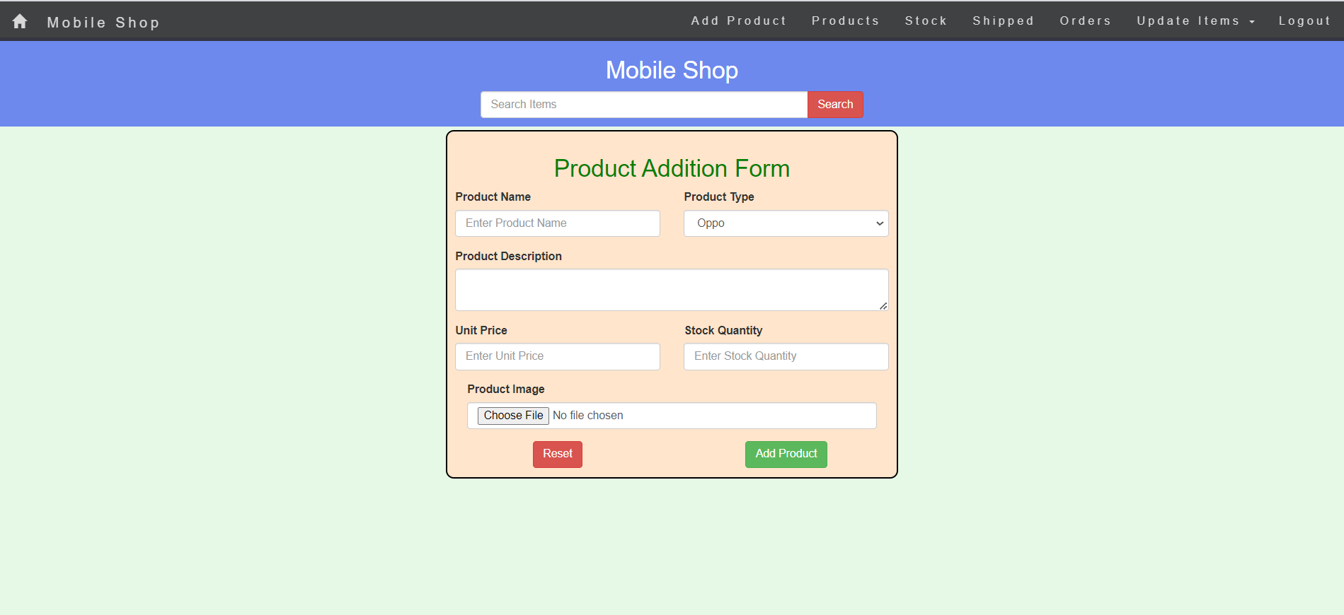

**Page Name: -** Admin Update product

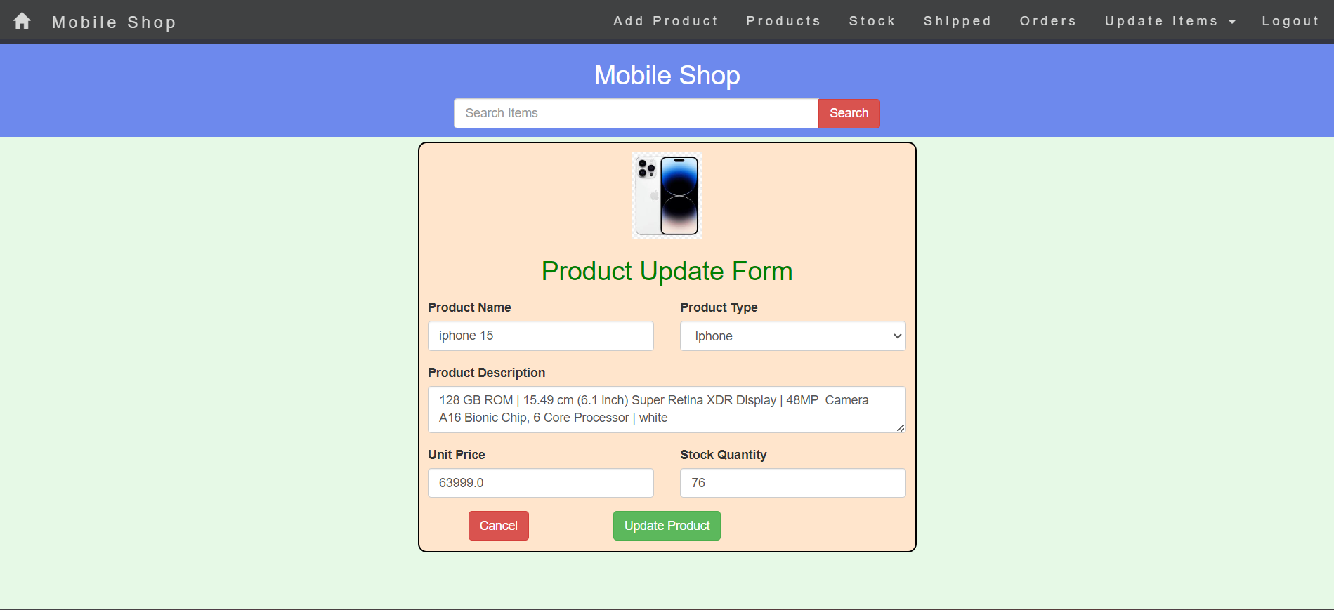



**Page Name: -** Admin View Pending Order

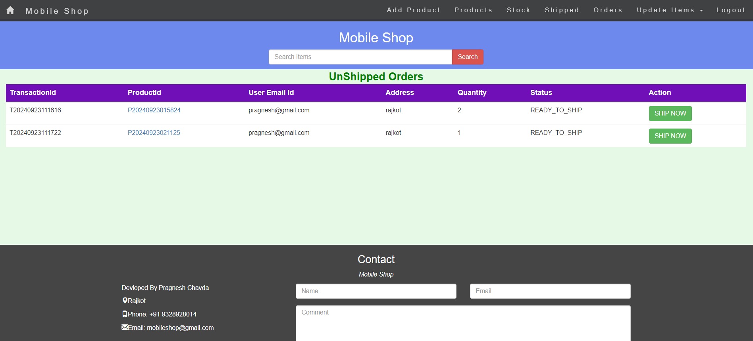

**Page Name: -** View Delivered Order



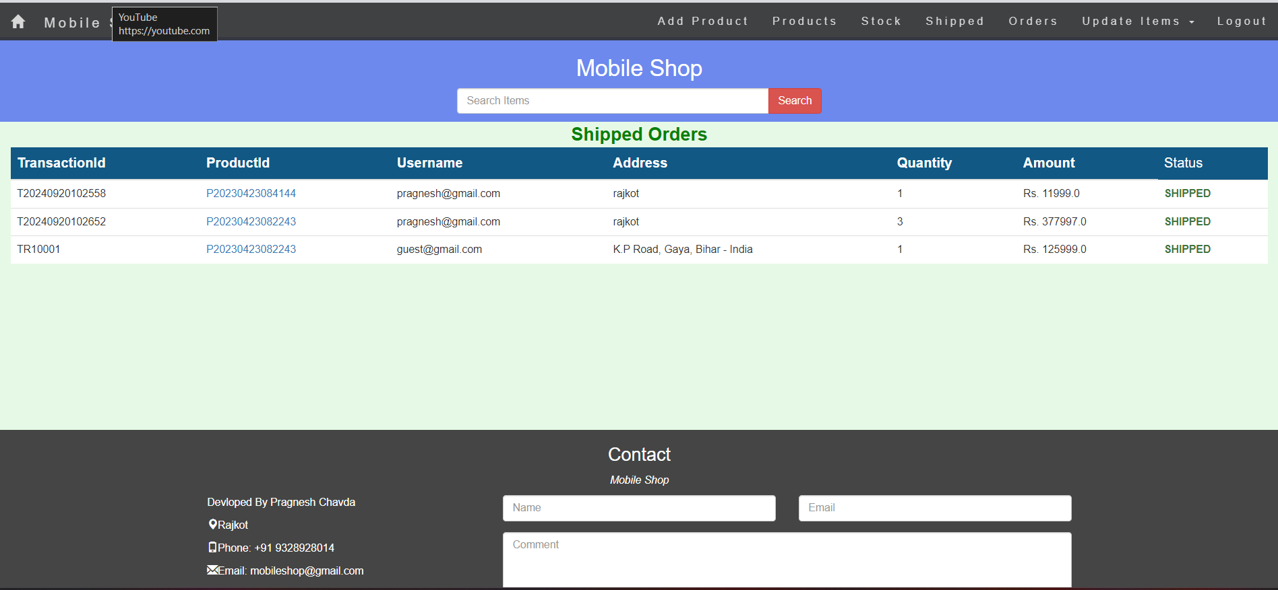

**Page Name: -** User Profile

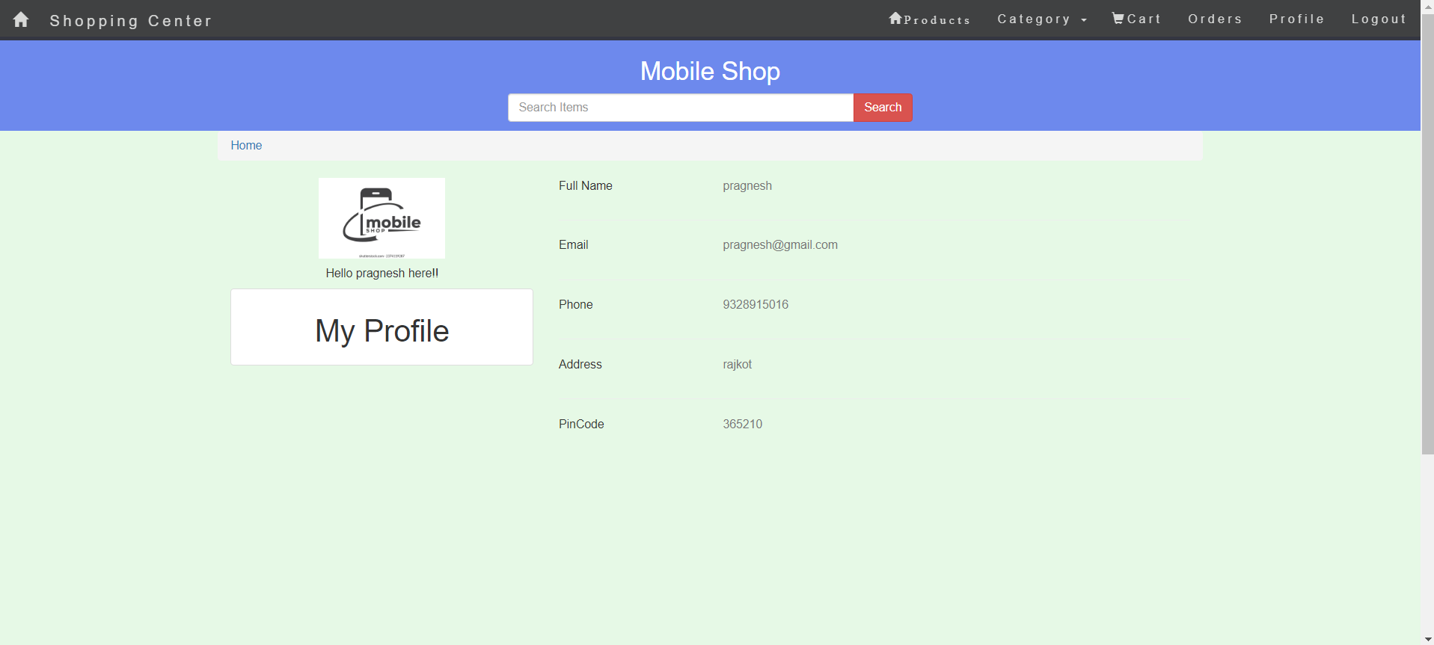

# FUTURE REQUIREMENTS OF PROJECT

* Future requirements for a **Mobile Shop Management System** involve enhancing user experience with AI- driven features, expanding integration capabilities, providing advanced tools for shop owners and customers, and ensuring scalability, security, and compliance. By implementing these requirements, the mobile shop management system can remain competitive, adapt to evolving market demands, and support growth in the fast-paced retail sector..

# LIMITATION OF PROJECT

The limitations of a **Mobile Shop Management System** include technical challenges related to scalability and integration, security and privacy concerns, and user experience issues such as accessibility and ease of use. Additionally, functional limitations, financial constraints, and the need for ongoing maintenance can present challenges. The rapidly evolving technological landscape and increasing competition in the retail market also pose risks. Addressing these limitations is crucial for the system’s long-term success.

# WEBLO GRAPHY

**Resources Used**



Google: <https://www.google.com/>

Stack Overflow: <https://stackoverflow.com/> ChatGPT by OpenAI: <https://chat.openai.com/> Javatpoint: <https://www.javatpoint.com/>

